(Approx. 739 words)

Logic Game Apps for Android and iPhones
By Dorothy Fitch, Editor, Green Bytes
GVR Computer Club
https://www.ccgvaz.org/

I seem to have become addicted to logic games on my Kindle (and sometimes my phone). I guess of all the possible addictions, this one would rank low in being troubling. However, these games can be time-consuming when I should be doing more productive things. So, I figure it might let me know if my mental faculties start to wane if I happen to notice.
How do I choose a logic game? I look for free games and read reviews. After downloading a game, I see how easy it is to learn to play it, whether it has a tutorial, and if there are either no ads or non-intrusive ones. These three games passed those tests. Beware, they can be addictive, and you may (as I did in one case) spend a tiny amount of cash to get more levels. However, because they are logic puzzles, you can generally play the same puzzle multiple times because you won't remember the layout or solution.
Here are my favorite three:

Thermometer Puzzles
Download to your Kindle from Amazon.
Download a version for your phone at the Play Store.
Download a version for your iPhone.
This puzzle comes with 260 games, but I'll confess to spending $5.99 for another 900 games. Nevertheless, it offers a good tutorial and a handy "undo" option.

The object is to fill the thermometers with mercury to have the correct number of red squares as indicated by the labels at the top and left sides. Unfortunately, the mercury starts at the "bulb" end of a "tube" and can't reappear after an empty cell. The difficulty ranges from grid sizes of 4x4 to 11x11 (or 13x13 if you purchase all the levels).
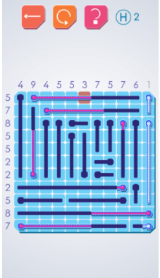
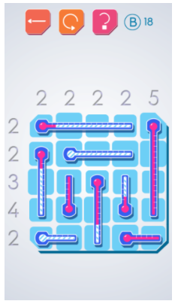
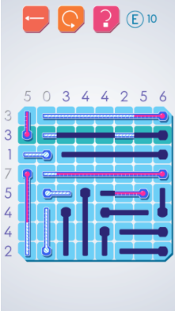

Click to enlarge any of these images.

The puzzles are untimed, and you can get unlimited hints. A row or column highlighted in green shows where you can make a move (but doesn't tell you what to do). An orange box indicates an error.
The phone version for Android or iPhones is from the same manufacturer but is slightly different. For example, it sometimes omits numbers that tell you how much mercury you need, which is an interesting twist. However, it has loud and long ads to wait through. So I use it in a pinch.

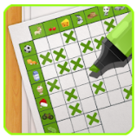
Real Einstein's Riddle
Download from the Google Play Store to a Kindle or phone.
Learn how to play (video).
Download from the Apple Store.

This puzzle comes with 5000 puzzles and 15 daily challenges, all for free.

The goal is to follow clues, eliminate the impossible combinations (shown in brown), and keep the good ones (in green) by tapping icons in the grid at the lower left. Although the text clues are initially helpful (it is fun to play the game in a foreign language!), you will eventually use the background colors of the boxes as your guide.

The "How to Play" tutorial is excellent, and the video (link above) is good, although it doesn't show that you can hold down (long press) on an image to remove all other occurrences of it in that row. Start with the easy levels, and you'll soon want to try the larger grids. You can save your position and later restore the puzzle to that point if you had to guess (which does happen in larger grids), and the path you initially took didn't work out.
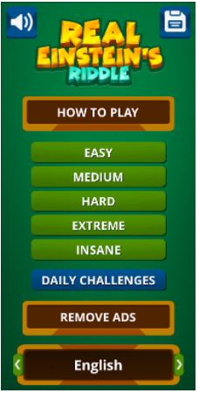
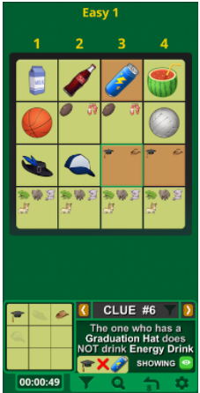
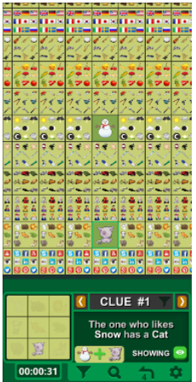

Click to enlarge any of these images.
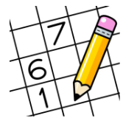
Sudoku
Download to your Kindle from Amazon.
Download to your Android phone at the Google Play Store.
Download to your iPhone from the Apple Store.
I probably don't have to introduce you to Sudoku. Although you put numbers into the grid (a different number from 1 to 9 in each row, column, and section), there is no math involved, just logic.
I like this particular version of Sudoku because there are no ads, there are unlimited puzzles, and many difficulty levels. In addition, you can add multiple numbers to each cell to aid in solving the more challenging ones. You can also save a game and complete it later.
I also use this version on my Android phone.
I recently read that the man credited with creating Sukodu and introducing it to the world has died. His story is here.
I hope you enjoy some of these puzzles as much as I do!

